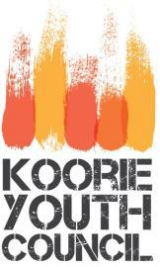
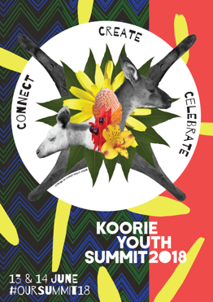

Expression of Interest
Stallholder
Event: Koorie Youth Summit Lunchtime Expo

Date: Wednesday 13th June
Time: 12.30pm – 1.30pm (Set Up: 12.15PM)

Venue: Pullman Melbourne on the Park (Ballroom Foyer) 192 Wellington Parade, Melbourne

What is the Koorie Youth Summit?

The Koorie Youth Summit is a place for Aboriginal young people to come together and share what's important. Each year our delegates gather from around the state to connect each other, celebrate our culture, discuss issues in our community, and share ideas to make change and create a future we want.

The Summit this year will focus on Indigenous culture and celebrating young people and the summit will feature a number of guest speakers and cultural activities.

This is expressed through our theme for 2018:
Connect, Create, Celebrate

The Koorie Youth Council looks forward to your application!

For more information, please contact Cienan Muir, Senior Project Officer on 9267 3707.

The Koorie Youth Council is seeking stall holders who can offer interactive and engaging activities along with important information for the delegates.

When the Koorie Youth Council receive your expression of interest application, we will then make a team decision on the appropriateness of your application

We take into account:

  - Your organisations work with Aboriginal young people in Victoria.

  - The type of work your organisation is involved in.

  - Relevance to event

  - Benefit to all delegates at event

If you are successful, you will receive an email notification from Fruitbowl Productions including an invoice for payment of your stall fee. To contact Fruitbowl Productions please call 1300 663 450 or email info@koorieyouthsummit.com.au

Any media enquiries must be taken to a Koorie Youth Council staff member in regards to any interview recording of the delegates.

The Koorie Youth Summit will have official photographer who must be notified if you would like any relevant pictures while at your organisations stall.

Stallholder Application Form
Organisation | Name:
 | Organisation address:
 | Description:
Contact Details | Contact person/s:
 | Mobile:
 | Work:
 | Email:
What are you advertising? | Do you have a youth focus?
It is encouraged that you run an activity which can be used to engage young people. Please describe your activity. | (e.g. photo Booth, Instagram competition)
Will you be providing any additional items for your stall set up? | (e.g. banners, signage)

Please send your form to info@koorieyouthsummit.com.au
Stall fee: $100 ex GST (Double sites available for $200)
Includes: 2m wide space, trestle table and tablecloth.
Backboards available on request at an additional charge.

