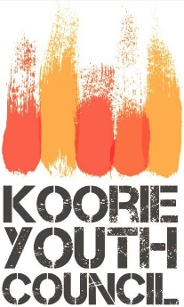

Koorie Youth Council
Media Release Form

I consent to the use of my name and any personal information that I may have provided in written form or as part of an interview with/ or on behalf of the Koorie Youth Council, all with any photographs, sound and/or video recordings of me, to be published on the Youth Affairs Council of Victoria (YACVic) website or in a third party’s publication authorised by the Koorie Youth Council as part of the Koorie Youth Council’s web, print and electronic publications and as required from time to time by the Koorie Youth Council including its use in advertising or marketing material produced by the Koorie Youth Council or third party on behalf of the Koorie Youth Council.

I accept that photographs of me may be digitally edited by the Koorie Youth Council or a third party authorised by the Koorie Youth Council. I acknowledge that the Koorie Youth Council will make every effort to ensure that the use of any personal information, photographs, sounds and/or video of me will not be used in a derogatory or demeaning manor.
I acknowledge that the Koorie Youth Council use or publication of personal information about me, including any photographs, does not give me any right to require payment, or any right to share in proceeds obtained through the use of the photographs.

Print Name: _____________________________

Signature: ______________________________ Date: _____________________

I, (Parent/Guardian) , acknowledge, understand and give the Koorie Youth Council permission for the above mentioned conditions on media release information for my child, ________________________. I acknowledge that the Koorie Youth Council will not use any personal information, photographs, sounds and/or video in a way that may endanger my child’s safety.

Signature: _____________________________ Date: ____________________

